Week 3 Deliverable

P33 Project

**MinimumViable Product (MVP):**

* Inputting Data
  + Cash flow
  + Expenses
  + Goals
* Budget Summary
  + Weekly
  + Monthly
  + Quarterly
  + Yearly
* Budget Analysis
  + Weekly
  + Monthly
  + Quarterly
  + Yearly

**MVP Flowcharts:**

* Website flowchart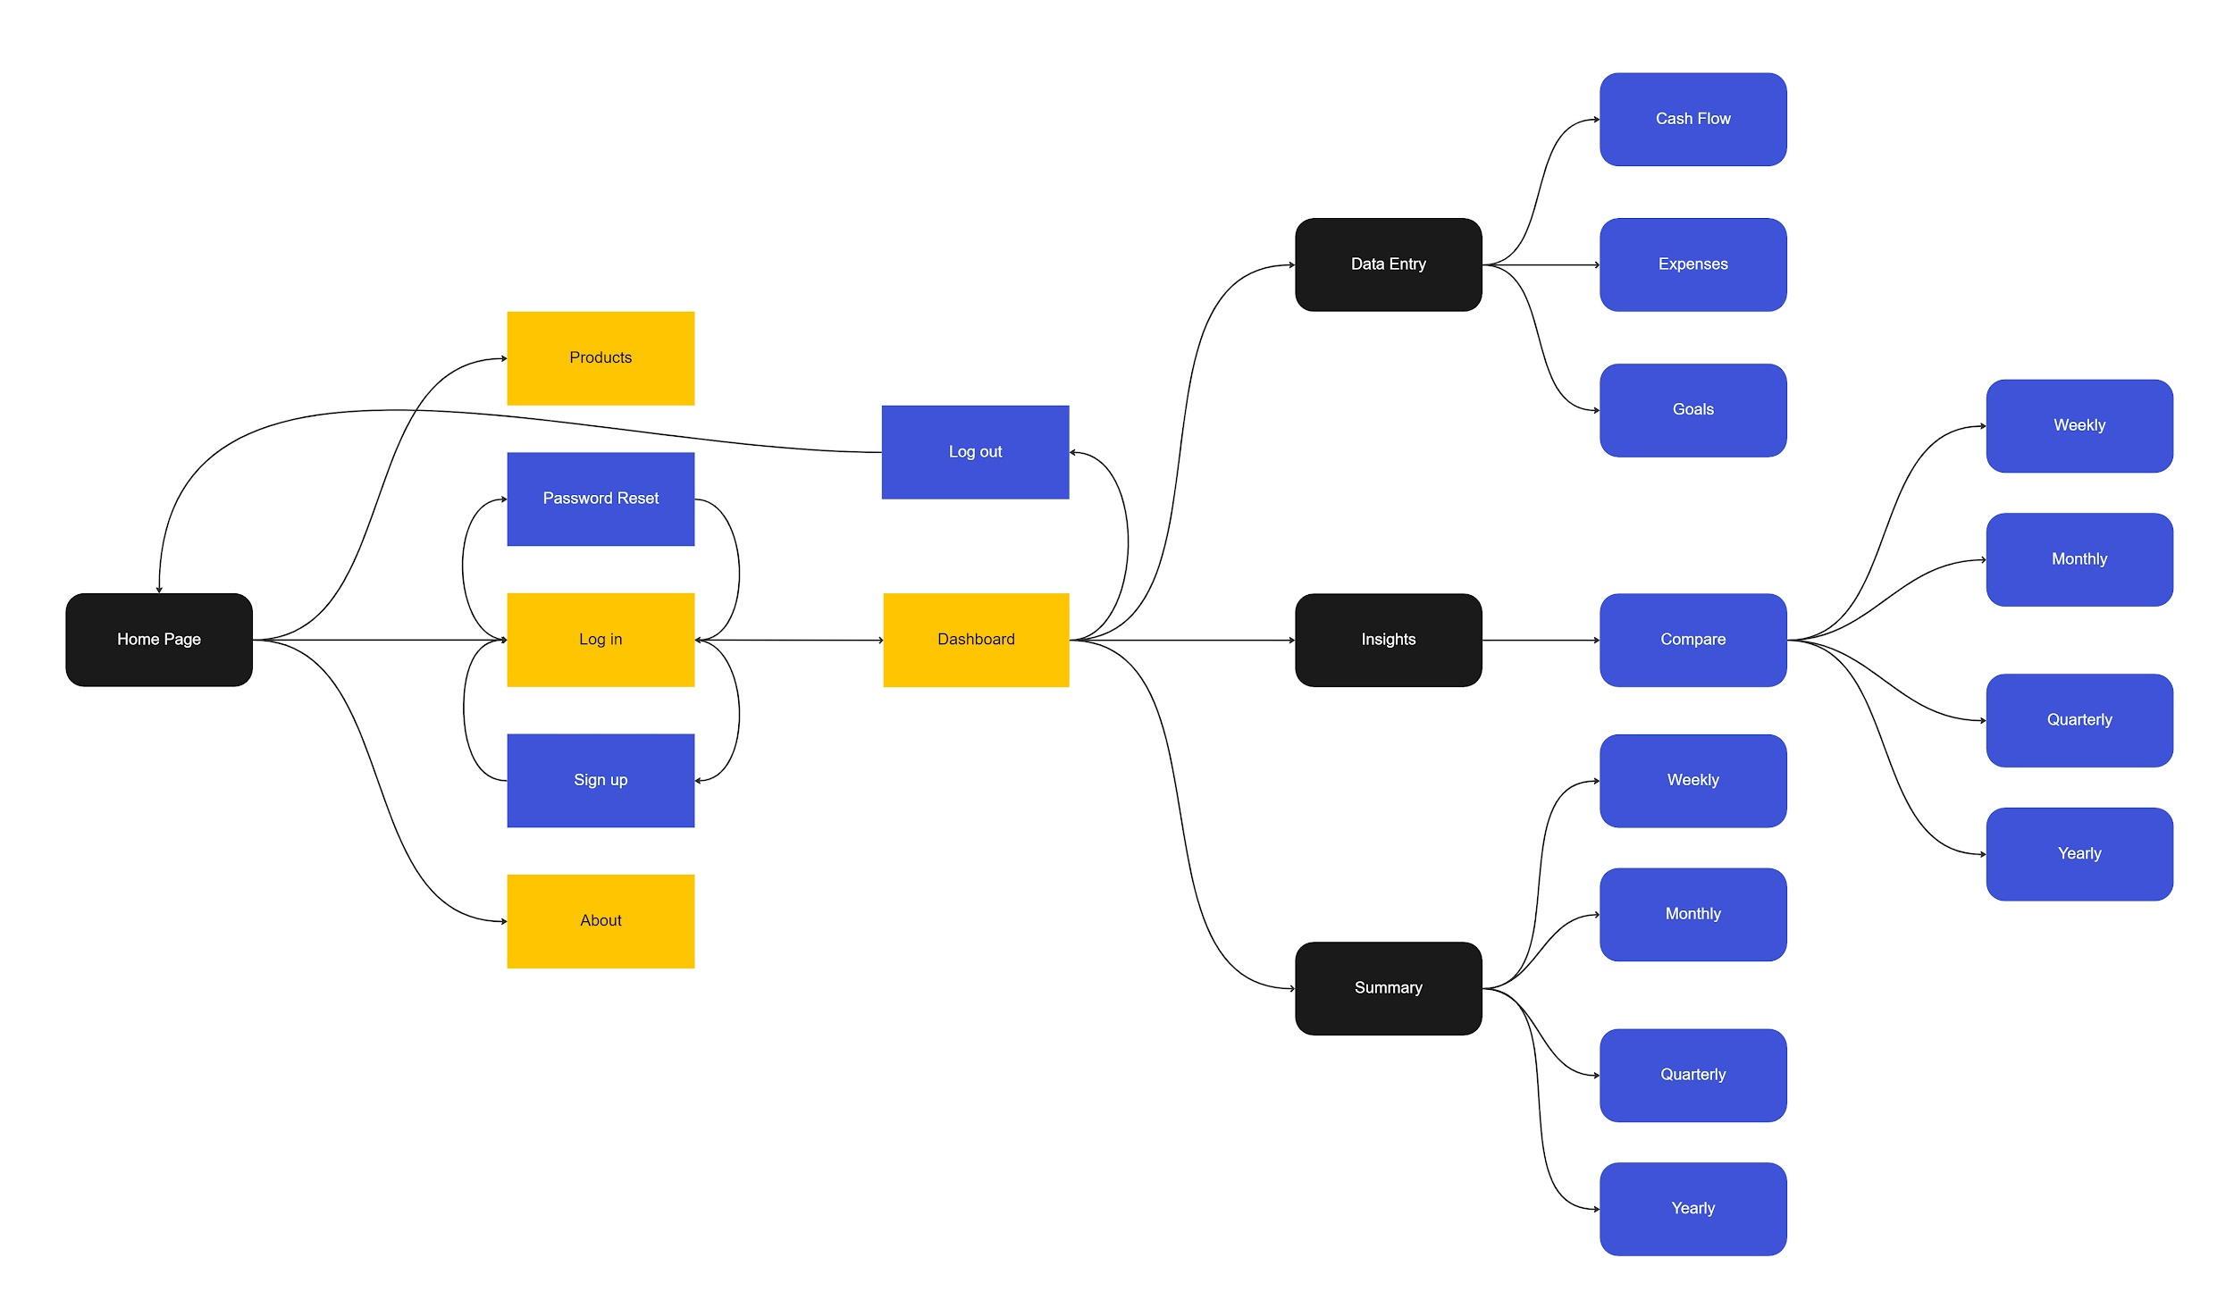
* Website flowchart with mockups

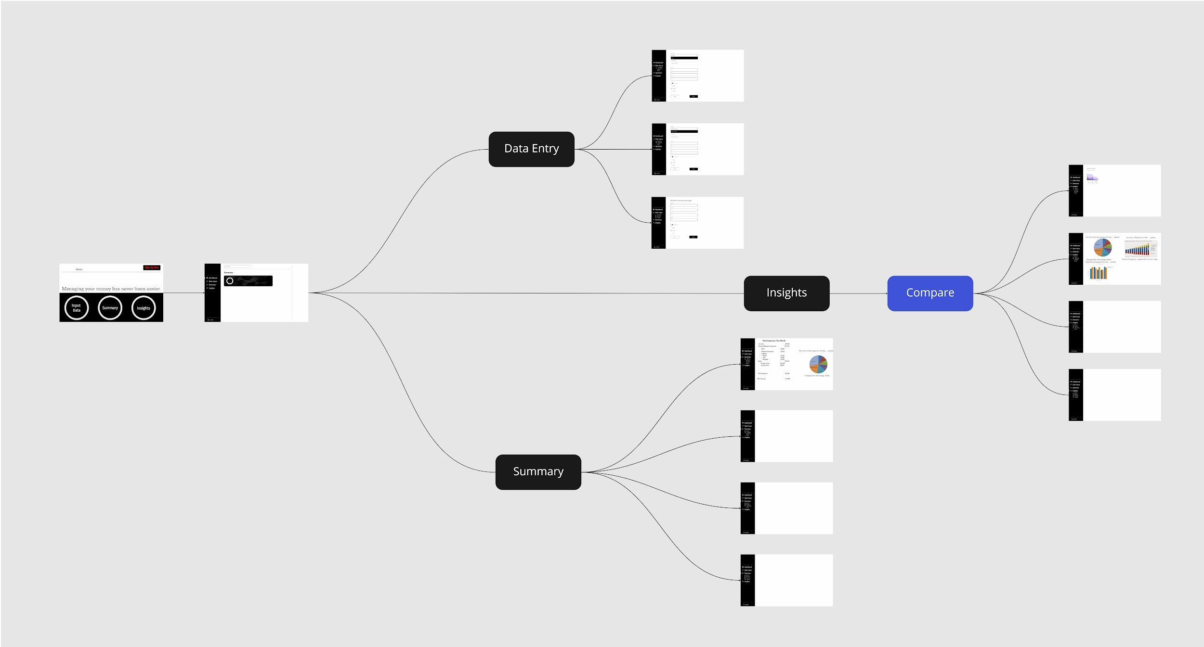

**Mockups:**

* Attached below for better resolution